Exercise 2- Implementing dependency Injection

1. BookRepository.java
2. package com.library.repository;  
     
   public class BookRepository {  
    public void displayBooks() {  
    System.*out*.println("📚 Showing all books from repository...");  
    }  
   }

3BookService.java

package com.library.service;  
  
import com.library.repository.BookRepository;  
  
public class BookService {  
 private BookRepository bookRepository;  
  
 // ✅ Setter for DI  
 public void setBookRepository(BookRepository bookRepository) {  
 this.bookRepository = bookRepository;  
 }  
  
 public void showBooks() {  
 bookRepository.displayBooks(); // call repo method  
 }  
}

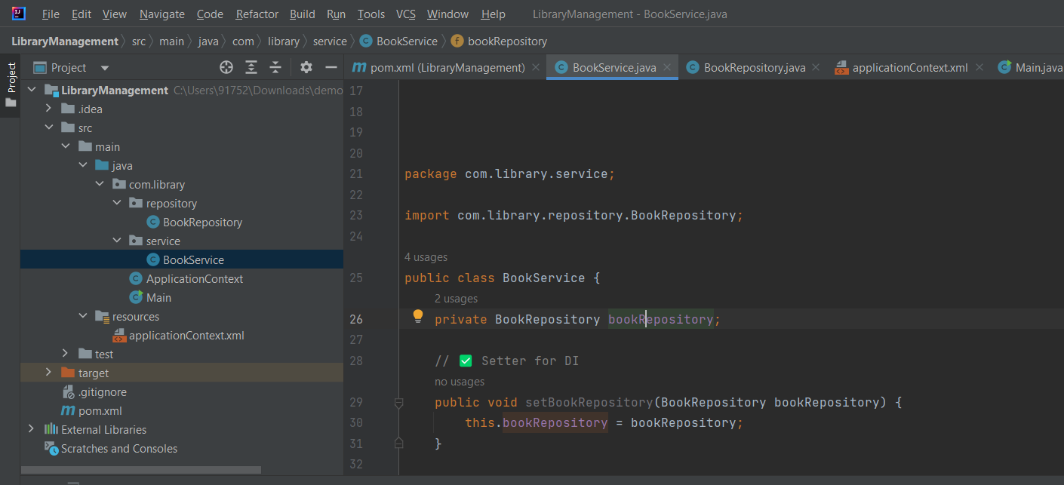

1. applicationContext.xml

<?xml version="1.0" encoding="UTF-8"?>  
<beans xmlns="http://www.springframework.org/schema/beans"  
 xmlns:xsi="http://www.w3.org/2001/XMLSchema-instance"  
 xsi:schemaLocation="  
 http://www.springframework.org/schema/beans  
 http://www.springframework.org/schema/beans/spring-beans.xsd  
http://www.springframework.org/schema/beans  
http://www.springframework.org/schema/beans ">  
  
 <!-- ✅ BookRepository Bean -->  
 <bean id="bookRepository" class="com.library.repository.BookRepository"/>  
  
 <!-- ✅ BookService Bean with injected repository -->  
 <bean id="bookService" class="com.library.service.BookService">  
 <property name="bookRepository" ref="bookRepository"/>  
 </bean>  
  
</beans>

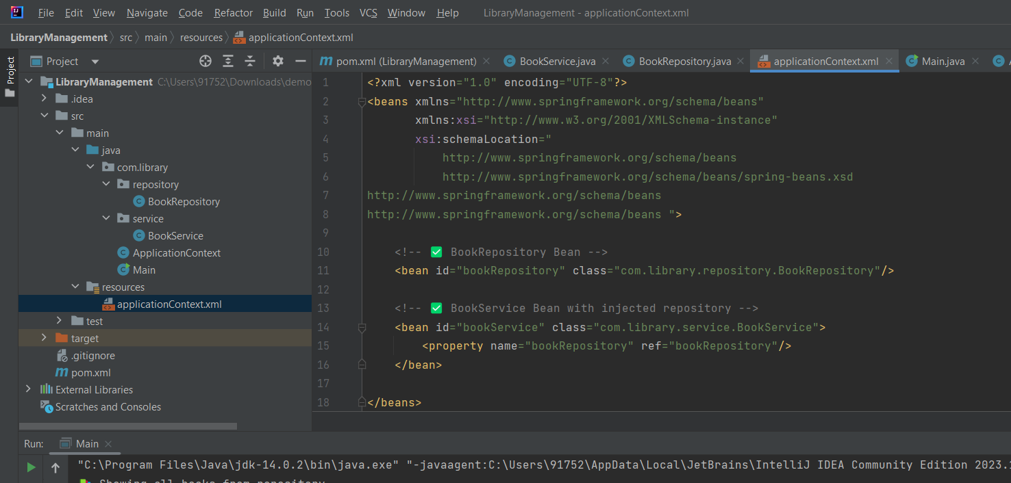

1. pom.xml

<?xml version="1.0" encoding="UTF-8"?>  
<project xmlns="http://maven.apache.org/POM/4.0.0"  
 xmlns:xsi="http://www.w3.org/2001/XMLSchema-instance"  
 xsi:schemaLocation="http://maven.apache.org/POM/4.0.0 http://maven.apache.org/xsd/maven-4.0.0.xsd">  
 <modelVersion>4.0.0</modelVersion>  
  
 <groupId>com.library</groupId>  
 <artifactId>LibraryManagement</artifactId>  
 <version>1.0-SNAPSHOT</version>  
  
 <properties>  
 <maven.compiler.source>14</maven.compiler.source>  
 <maven.compiler.target>14</maven.compiler.target>  
 <project.build.sourceEncoding>UTF-8</project.build.sourceEncoding>  
 </properties>  
 <dependencies>  
 <dependency>  
 <groupId>org.springframework</groupId>  
 <artifactId>spring-context</artifactId>  
 <version>5.3.34</version>  
 </dependency>  
 </dependencies>  
  
</project>

1. OUTPIT

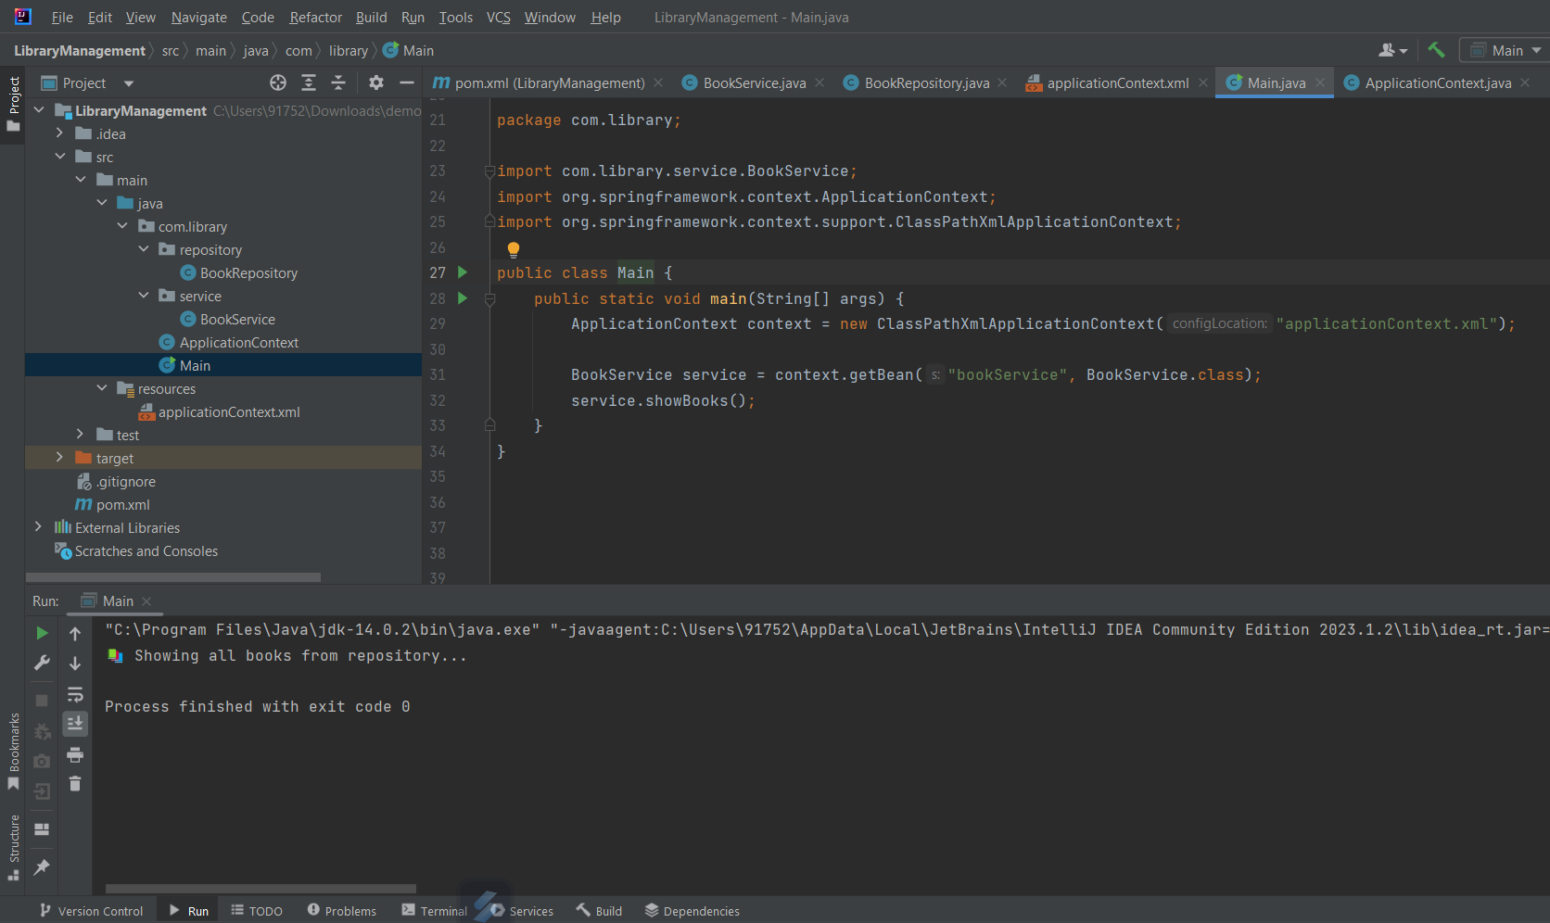

1. Main.java

package com.library;  
  
import com.library.service.BookService;  
import org.springframework.context.ApplicationContext;  
import org.springframework.context.support.ClassPathXmlApplicationContext;  
  
public class Main {  
 public static void main(String[] args) {  
 ApplicationContext context = new ClassPathXmlApplicationContext("applicationContext.xml");  
  
 BookService service = context.getBean("bookService", BookService.class);  
 service.showBooks();  
 }  
}